


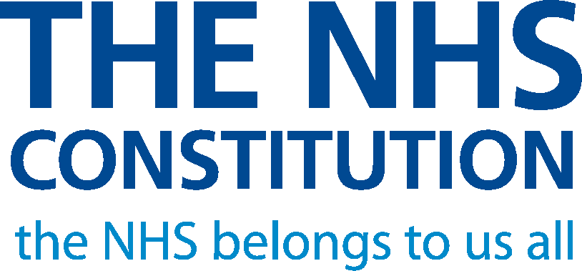
Easy read
for England
8 March 2010

This is an Easy Read booklet which tells you about the NHS Constitution and the Handbook which goes with it.
When we say we in this booklet we mean the National Health Service or NHS for short. |  | 
When we say Constitution we mean the NHS Constitution. |  | 

When we say Handbook we mean the booklet called The Handbook to the NHS Constitution.
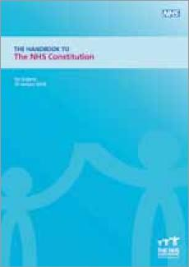
There are some difficult words in this booklet. There is a list of these words and what they mean on page 30.
These words are in red letters in the booklet.

You may like to have someone to support you when you look at this booklet.

What is in this booklet?
1
What is this booklet about? 2
The NHS Constitution – What is it? 5
The Constitution and the law 8
The Handbook – What is it? 9
What is in the Constitution? 11
Our principles 12
Rights for patients and the public 14
Pledges to patients and the public 17
Rights for staff doing NHS work 20
Pledges to staff 22
Responsibilities for patients and the public . . . . . . . . . . . 23
Responsibilities for staff 25
NHS values 28
What the words mean 30
How to find out more 31

What is this booklet about?
The NHS belongs to everyone. It is there to help all of us:

- To have better health.

2
- To keep our bodies well.
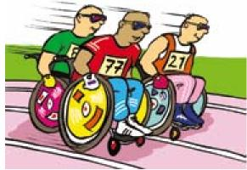
- To keep our minds well.


The NHS is there to help us when we need help most.
• To stay well. | 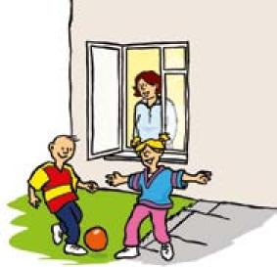

- To get better when we are ill. | 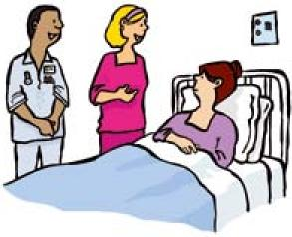
- To look after us if we cannot get better. | 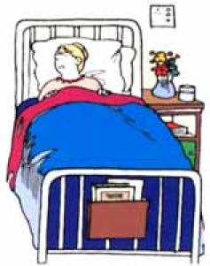
3

We have written the NHS Constitution and the Handbook to explain how
the NHS should work in the future.
This booklet tells you about:
- the NHS Constitution
- the Handbook which goes with the Constitution.

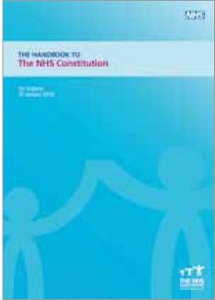

You can see the full-length versions of the Constitution and the Handbook at www.nhs.uk/aboutnhs/Constitution


4
The full-length versions are not written in Easy Read.

The NHS Constitution – What is it?

- our patients
- the public
- everyone who does NHS work in England.
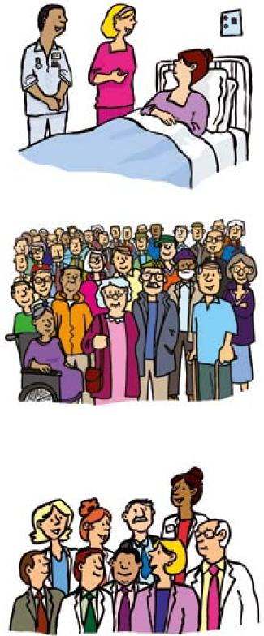
5
The Constitution is an important part of our plans to make it clear  to patients, the public and our staff what they can expect from the NHS. It brings this information together in one place for the first time.  We have written the Constitution for: | 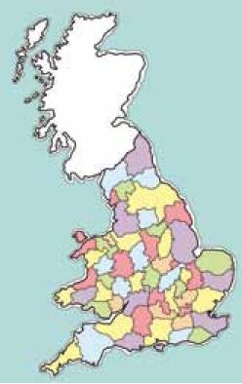

Before we wrote the Constitution we talked to a lot of people. We talked to patients, the public, our staff and other experts.

(Our staff are the people who work for us.)

You can read about what people told us on our website: www.dh.gov.uk/nhsconstitution

The Constitution will:
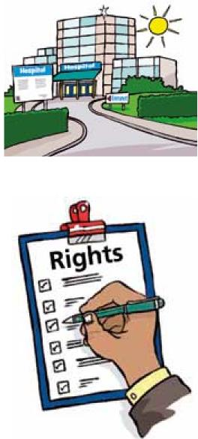
- Make sure the NHS can continue
to do a good job in the future.
- Give power to patients and the public. We want everyone to know what services they can get and what to do if they do not get them.

6
- Explain what patients, the public and NHS staff should do to help the NHS. | 

• Tell our staff that they are the most important part of the NHS. | 

7

We first published the Constitution on 21 January 2009.

The Constitution and the law

The law says the NHS, private providers and third sector providers of health services must use the Constitution when they plan and give services. (Third sector means organisations like charities, local groups and voluntary organisations.)
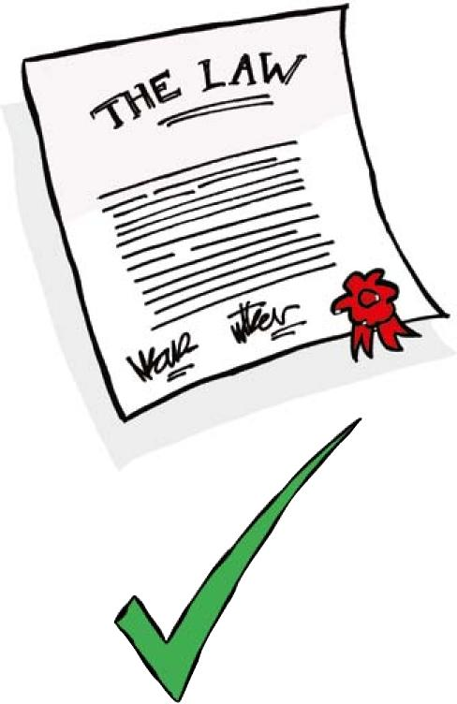
8
No one will be able to change the Constitution without asking patients,
the public and our staff what they think.
We will check the Constitution every 10 years to make sure it is still doing a good job. We will do this with the help of patients, the public and our staff.

The Handbook – What is it?

We have also written The Handbook to the NHS Constitution. | 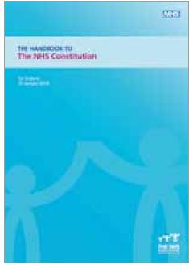

The Handbook:


9
- Gives more information about what it says in the Constitution.
- Helps everyone to understand what they can expect from the NHS.

The Handbook also:  - Gives advice about what we all have to do to help the NHS do a good job. | 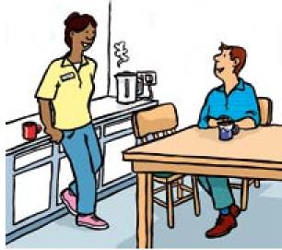

- Gives information about what to do if you are not happy with the service you get from the NHS. | 

10
- Explains more about the law. | 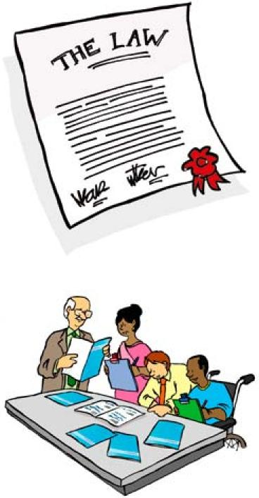
We will look at the Handbook at least every 3 years.
We will change it before that if we need to.

What is in the Constitution?

The Constitution tells you:
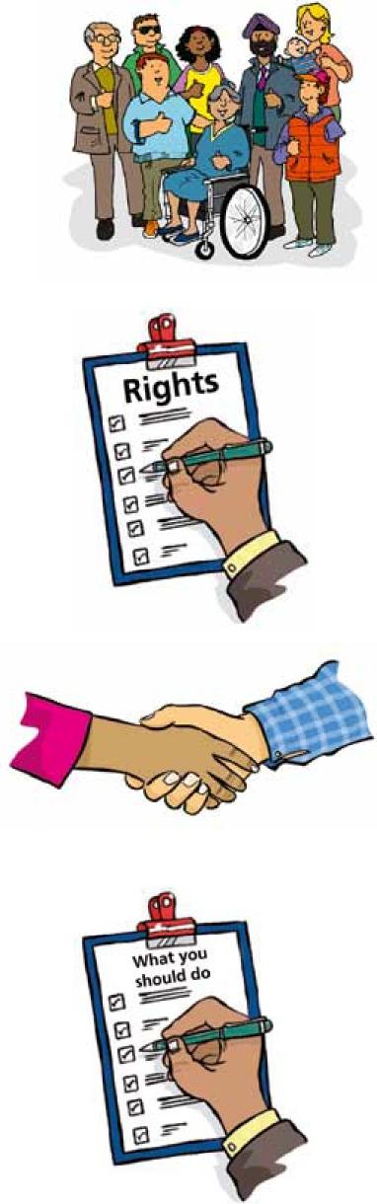
11
- What is important to the NHS – our principles and values.
- What people can expect from us – their rights.
- What we want to do – our pledges.
- What we expect from patients, the public and staff – their responsibilities.
We tell you more about all these things on the next pages.

Our principles  The principles are the most important things that the NHS believes it should do.  We have 7 main principles: | 

12
- The NHS should be for everyone whatever their age, sex, race, disability, sexual orientation, religion or belief.  - To have free health care as far as possible, as long as Parliament agrees or says you can.  - We will give high quality care. | 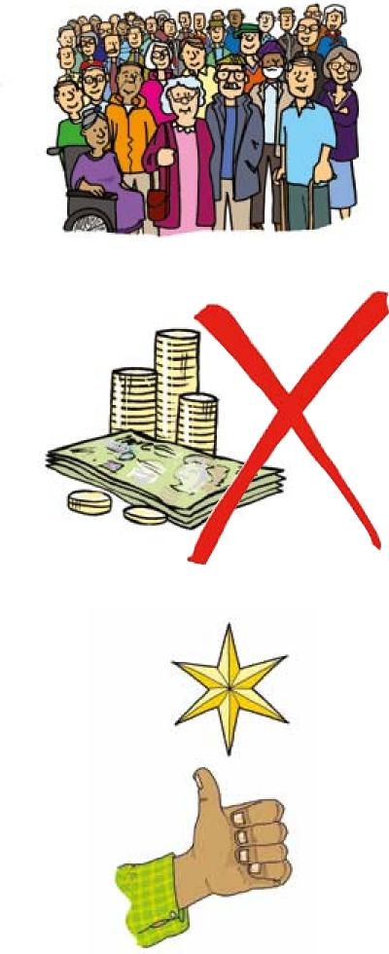

4. We will involve patients and carers in deciding about their care. | 

5. We will work with other services to give better health care. | 
6. We will spend tax payers’ money carefully. | 
7. We will be open about how we spend the money.
13

Rights for patients
and the public
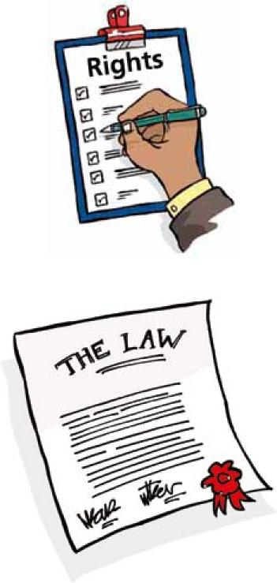
The Constitution explains your rights. These are what patients and the public can expect from the NHS.
Rights are protected by the law. Everyone should know what their rights are.
Here are some of the rights for patients:
- To have free health care as far as possible, as long as Parliament agrees or says you can.

14
- To have high quality care.
- To access health services quickly. You can ask to be offered an appointment somewhere else if this is not possible.

• To have the medicines that have been approved by NICE (NICE is the organisation that says which medicines doctors should use)  or authorised by your Primary Care Trust (PCT). | 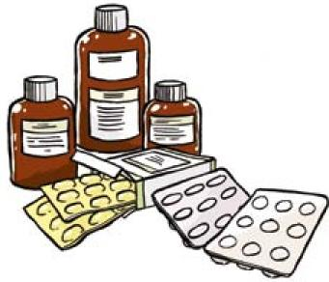

- To be treated fairly and with respect. | 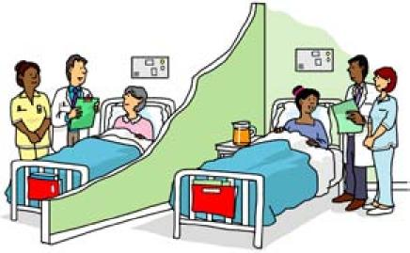
- To say what care you do or do not want. | 

15
- To be given information about your care. | 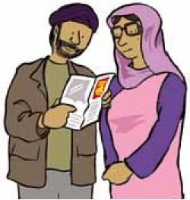

Here are some more of the rights for patients:  - To choose your doctor. | 

- To be involved in making decisions about your care. | 

The Constitution has a full list of all your rights.

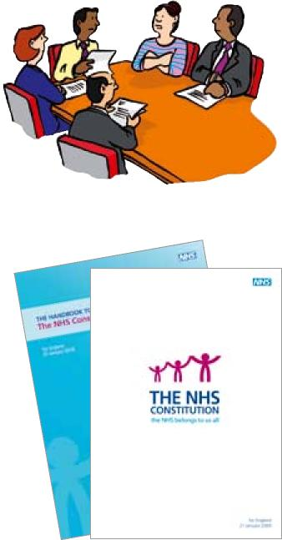
16
The Handbook tells you more about your rights and the law. It also tells you what to do if you are not happy with the way you have been treated.

Pledges to patients
and the public
Our pledges are the things we plan to do to make the NHS better for patients but which are not laws. | 

Here are some of our pledges to patients:

- To make sure it is easy to access health services. | 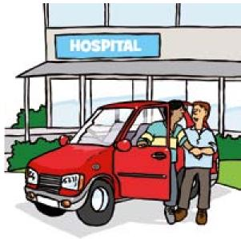

17
- To make sure health services are high quality. | 

Here are some more of our pledges to patients:  - To screen people who might have health problems. (Screen means to test a person for an illness.) | 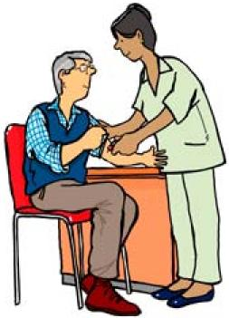

- To give you copies of letters about your care. | 

18
- To give you the information you need to help you make choices about your care. | 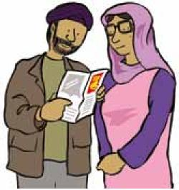

• To work with you, your family and carers. | 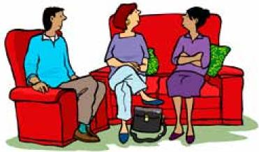

• To listen and learn from what you say if you complain about services. | 
19

The Constitution has a full list of our pledges to you.

Rights for staff doing
• have a good place to work | 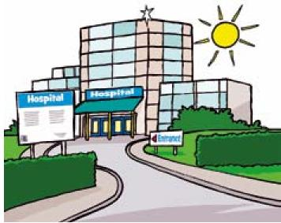
20
NHS work
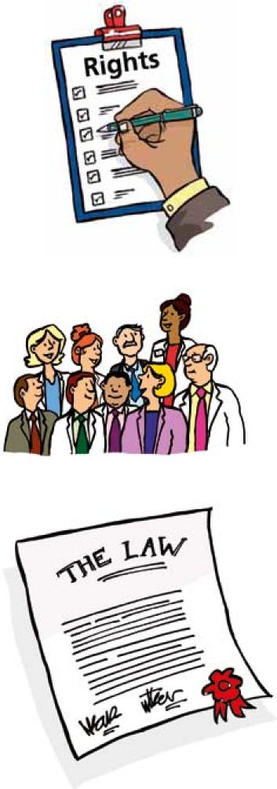
The Constitution is for all our staff in the NHS, and in public, private or third sector organisations.
It is our staff that make sure that the NHS gives good quality health care.
It is important that we give all our staff the support they need to do a good job.
The Constitution explains the rights our staff have. These are things our staff can expect from the NHS by law.
The rights help make sure that staff:

• have fair pay

21
- are involved in making decisions

- are treated fairly

- can complain if they are not happy.
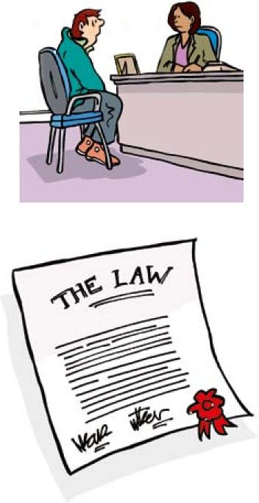
Our staff have other rights from laws to do with work and discrimination. The Handbook tells you more about these other rights.

Pledges to staff
Our pledges to our staff are the things we plan to do to make the NHS a better place to work.

22
Here are some of our pledges to our staff:

- To make it clear what we expect from staff.
- To give good training and support.
- To help them stay safe and well.
- To involve them in making decisions.

Responsibilities for patients
23
and the public
Responsibilities are the things you should do to help the NHS.

The Constitution says how patients and the public can help the NHS do a good job and to use money fairly.
Here are some of the responsibilities for patients and the public:
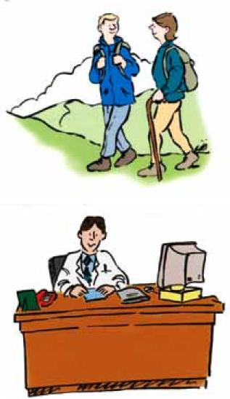
- To look after your health.
- To register with a doctor.
- To be polite to NHS staff and other patients.
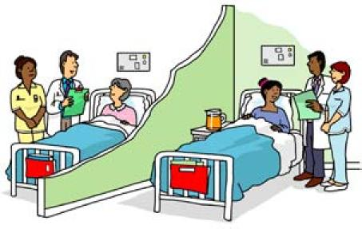

24
Here are some more of the responsibilities for patients and the public:
- To give us the right information about yourself and your health.
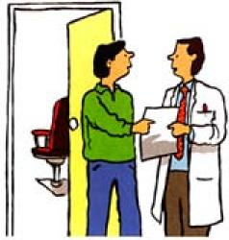

- To keep appointments, or let us know if you cannot come. | 

- To do your best to do what your doctor tells you.  - To let us know how your treatment has affected you. | 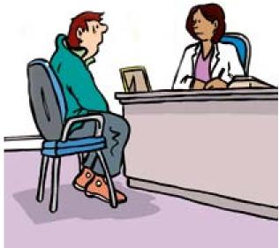

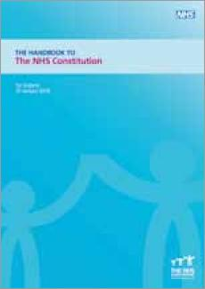
The Handbook tells you more about what you can do to help the NHS.

Responsibilities for staff
All staff have responsibilities to the public, their patients and the people they work with.
Here are some of the responsibilities for staff:

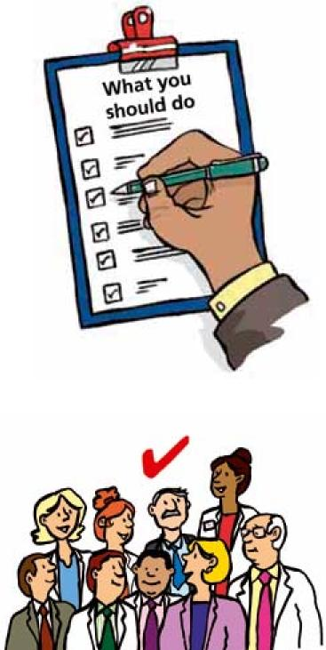

- Not to discriminate against patients or staff.
25
- To take responsibility for what they do.
- To look after their own health and safety and the health and safety of the people they work with.

Here are some more of the responsibilities for staff:
- To keep information about patients private. | 
- To be honest and truthful. | 
- To do the training they need to help them get better at their jobs. | 
26

• To work with patients and the public to make services better. | 

- To involve patients in  making decisions. | 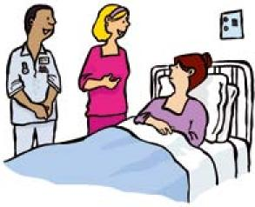
27
- To be open and clear in the information they give patients, their families and carers. | 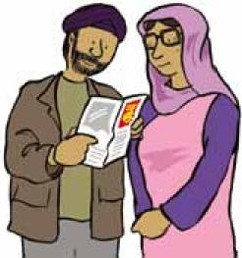

NHS values

Our values are the things we believe are most important in a modern NHS. We made our list of values after talking to patients, the public and staff.
We have 6 main values:
- Respect and dignity
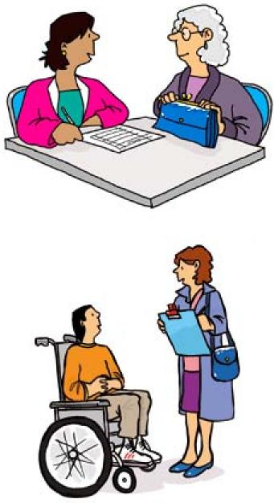
We respect everyone as a person. We will listen to them and be honest in what we tell them.
- Commitment to quality of care We work hard to get things right. We want to hear what people think of us. We will listen and learn from what people tell us.

28
3. Compassion  We care about our patients. We will be kind to people.  We will do what we can to make them feel better and happier. | 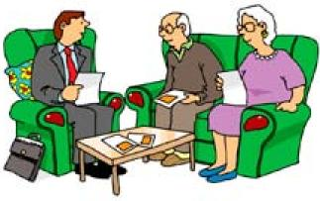

29
- Improving lives  We try to make people’s lives better. We want people to have good experiences of the NHS. | 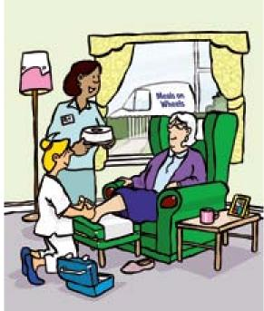

- Working together for patients We put the needs of patients first. We will make things as easy as possible for patients when we plan how we run our services. | 

- Everyone counts  We make sure no one is left out or forgotten. We know that some people need more help. We know that we should be careful not  to waste things like money. | 

What the words mean
30
Constitution | The NHS Constitution
discriminate or discrimination | Being unfair to someone because of their illness, disability, race, sex, religion or age
Handbook | The Handbook to the NHS Constitution
Handbook to the  NHS Constitution | A book which gives more information about the Constitution
NHS Constitution | A booklet which explains our plans to make the NHS in England work better in future
pledges | The things we plan to do to make the NHS better for patients, the public and our staff
principles | The most important things that the NHS believes it should do
responsibilities | The things everyone should do to help the NHS
rights | The things our patients, the public and our staff can expect from the NHS by law
sexual orientation | Whether someone is sexually attracted to men, women or both
staff | The people who do NHS work in England
values | The things we believe are most important in a modern NHS
third sector | A name for organisations like charities, local groups and voluntary organisations

How to find out more
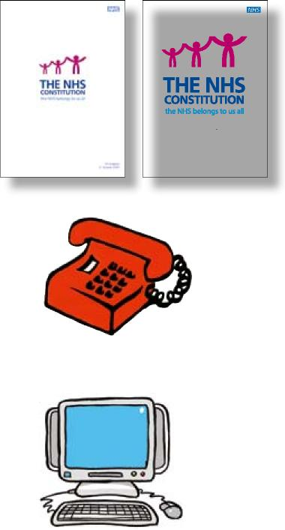
Easy read
for England 21 January 2009
31
If you want more copies of this booklet, or a copy of the full-length NHS Constitution you can:
Telephone: 0300 123 1002
Visit www.orderline.dh.gov.uk
Email dh@prolog.uk.com
Write to:
DH Publications Orderline PO Box 777

London SE1 6XH

Please tell us whether you want the Easy Read version (order number 302173 or the full-length
NHS Constitution (order number 300635) when you contact us.

You can also get a copy of the full-length NHS Consitution booklet from: | 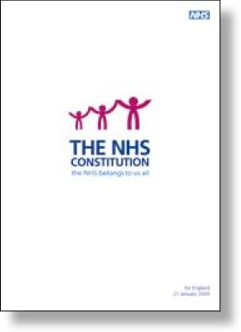
- doctors | 
- dentists | 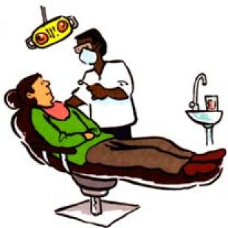
32

33
Or you can read it on our website: www.nhs.uk/aboutnhs/Constitution | 


© Crown copyright 2010
www.dh.gov.uk/publications
Produced by COI for the Department of Health 302173 March 2010

